

CONFIRMATION 2
Gr. 9

INFORMATION

NEEDED

FOR THE

CELEBRATION

OF THE

SACRAMENT

OF

CONFIRMATION

2026-2027

2026-2027

List of Requirements & DUE DATES

- Confirmation Retreat - Spirit Fire – 11/1

- Confirmation Service Part 1 Completed (4 hours)-11/8

- Sponsor Name and Sponsor Affirmation Form – 11/22

- Confirmation Service Part 2 Completed (3 hours)-1/10

- Confirmation Service Part 3 Completed (3 hours)-3/21

- Faith Hours (Youth Group) (5 hours) – 3/21

WHO CAN BE A SPONSOR?

- A person who is at least 16 years of age.
- A person who is Catholic, confirmed and who has already received the Eucharist.
- A person who leads a life in harmony with the faith including attending Mass on a regular basis.
- A person who, if married, was married in accordance with the requirements of the Catholic Church.
- A person who will later help the Confirmed to fulfill his/her Baptismal promises and Confirmation commitment.
- A person who will be present for rehearsal and the ceremony.

NOTE:

- To show the relationship between Baptism and Confirmation, it is encouraged but not necessary to have a Baptism godparent as the Confirmation sponsor.
- Only one sponsor can be chosen.
- The sponsor need not be the same sex as the Candidate.
- A father, mother, or step-parent may not be the sponsor.

Sponsor Affirmation Form

A Sponsor Affirmation form is to be downloaded from the Confirmation webpage, completed and signed by the sponsor. Please scan or take a photo of this and put in google classrooms by 11/22 before handing in the hard copy to Sr. Karen.
A Sample of this form follows on the next page.

https://saintjuniperoserra.org/confirmation-resources/

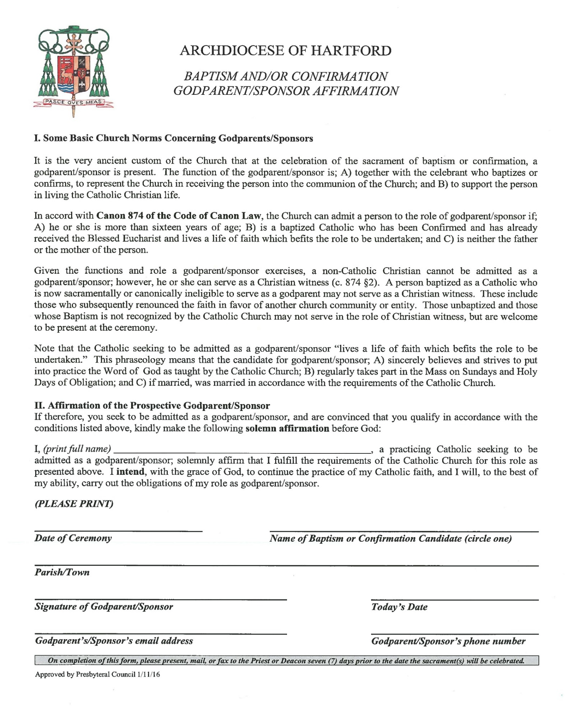

Confirmation Preparation at St. Junipero Serra
Confirmation Service Requirements
Along with forming a deeper interior faith, youth ministry in the Archdiocese of Hartford has the major goals of integrating young Catholics into the ongoing life of the parish and guiding young Catholics toward actively following Jesus Christ. The Confirmation Classes aim at the first goal, while the Confirmation Service Component aims at the second and third.
St. Junipero Serra Confirmation Candidates are required to volunteer for 10 hours 1st year and 10 hours 2nd year of service. The two areas they may volunteer in involve the Life of the Parish and the Corporal Works of Mercy.
- Life of the Parish at St. Junipero Serra Parish– Donut Sunday, Bingo, bulletins, Altar Server, Choir, Lector, Greeter, Usher, replace hymnals in pews, Bingo, decorate Church for holiday or wedding, serve at parish function, etc.
- Corporal Works of Mercy – Actively assist those suffering, outside Church walls.
  - Feed the hungry/give drink to the thirsty – St. Vincent de Paul or other food drives.
  - Shelter the homeless – go on parish trip to one of the homeless shelters, Habitat for Humanity.
  - Clothe the naked – Assist a winter clothing drive.
  - Visit the sick – helping seniors, spend time with someone homebound or in hospital.
  - Bury the dead – make and send a card to the family of a deceased person. Spend time with widow(er).
  - Visit the prisoners – probably wait until you’re older for this one.

DUE DATES: There will be 3 deadlines at which time approximately 3-4 hours should be completed by each deadline and hard copies of form handed in:
Part 1: 11/8 Part 2: 1/10 Part 3: 3/21

Below is the ACCEPTABLE list of service hour activities, all other activities require permission from Sr. Karen

- Communion Breakfasts
- Youth Group Setups and Cleanups
- Tootsie Roll Drive (with Knights of Columbus)
- Decorating the Church at Christmas, joining Student Christmas Choir
- Participates in the Shadow Stations of the Cross during Lent
- Preparing Simple Suppers during Lent
- Parish Golf Tournament
- Parish Summer Picnic – setup, work during, cleanup
- Family Bingo
- Helping set up before and clean up after Catechism Classes, and WPC, etc. (This cannot interfere with attending one’s own Confirmation class.)
- Spring or Fall Parish Cleanup
- St. Vincent De Paul Collections (monthly)
- East Hartford Family Shelter and Hartford Immacare shelter events & Service
- Harbor Chase and Residence senior activities – i.e. Games, Dances, Greeting cards, Crafts
- Prepare food for Shelters
- Make food baskets or blessing bags for Homeless or those with food insecurities
- Make and give out Brian Bags for the homeless.
- Help or participate in the parish Easter Egg Hunt or Nativity Play
- Help at local foodbank, pantry, or soup kitchen (with adult)
- Help elderly neighbor with task (un-paid and NOT a family member)

Any service hours completed in the summer before Confirmation classes can be included.
Note: All St. Junipero Serra sponsored events must have Virtus Certified adult(s) supervision.

. ***If an activity takes place outside of the church or this list, please have it
approved by Sister Karen beforehand.

Faith Hours – Fun and Faith or Youth Group Activities – due by 3/21

