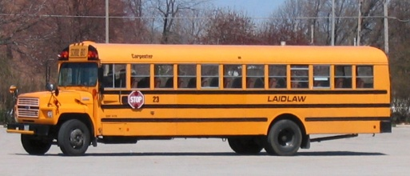
Rules for the Bus – please keep!

If your child needs to ride a different bus or doesn’t normally ride a bus, you need
to contact Joe Neuner (573) 659-6886 to see if there is room available.
With the exception of bus #1 you will need to call
Roger Temmen (573) 680-4538.

NOTE FROM HOME:
If they say your child can ride a different bus, you will need to send a Blue Note from Home to school prior to that day stating:

1. Talked to Joe/Roger on: ______________ (date)
2. My child: __________ (name and grade)
3. Will ride bus # ________
4. On Date: _____________
5. (AM) or (PM) Routes: _________
6. The bus needs to take your child to: _________________________________

