FEBRUARY 2026 Menu
- We are an equal opportunity employer Menu Subject to Change
SUNDAY | MONDAY | TUESDAY | WEDNESDAY | THURSDAY | FRIDAY | SATURDAY
1 | 2 | 3 | 4 | 5 | 6 | 7
 | BBQ meatballs  Hash brown casserole  Carrots  Pears | Chicken fajitas  Refried beans or rice  Corn  Fruit cup | Cheeseburger mac  Green beans  Apricots  Strawberry shortcake | Chicken nuggets  Macaroni & cheese  Peas  Peaches | Fish sandwich  Oven fries  Steamed broccoli  Pineapple tidbits
8 | 9 | 10 | 11 | 12 | 13 | 14
 | Chicken Tettrazini  Green beans  Pears  Sheet cake | Pulled pork/bun  Potato wedges  Peas  Applesauce | General Tsao's chicken  Rice  Carrots  Peaches | Spaghetti  Garlic bread  Corn  Mixed fruit | NO SCHOOL | 
15 | 16 | 17 | 18 | 19 | 20 | 21
 | NO SCHOOL | Beef Stroganoff  Green beans  Mixed fruit  Cookies | Tuna noodle casserole  Peas  Applesauce  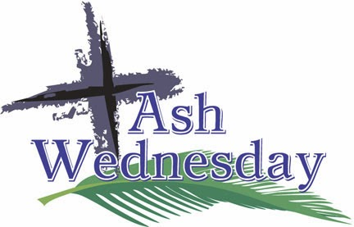  This Photo by Unknown Author is licensed under CC BY-NC-ND | Biscuits/sausage gravy  Scrambled eggs  Hash browns  Peaches | Chips/nacho cheese  Refried beans or rice  Corn  Pears
22 | 23 | 24 | 25 | 26 | 27 | 28
 | Hot dogs/chili dogs  Tator Tots  Peas  Mixed fruit | Swedish meatballs  Pasta  Green beans  Peaches | Assorted pizzas  Breadsticks  Carrots  Fruit cup | Chicken fettuccini  Corn  Apricots  Brownies | Grilled cheese  Tomato soup  Broccoli  Strawberries
*PBJ or PB offered daily *Salad bar available daily *Milk available daily

