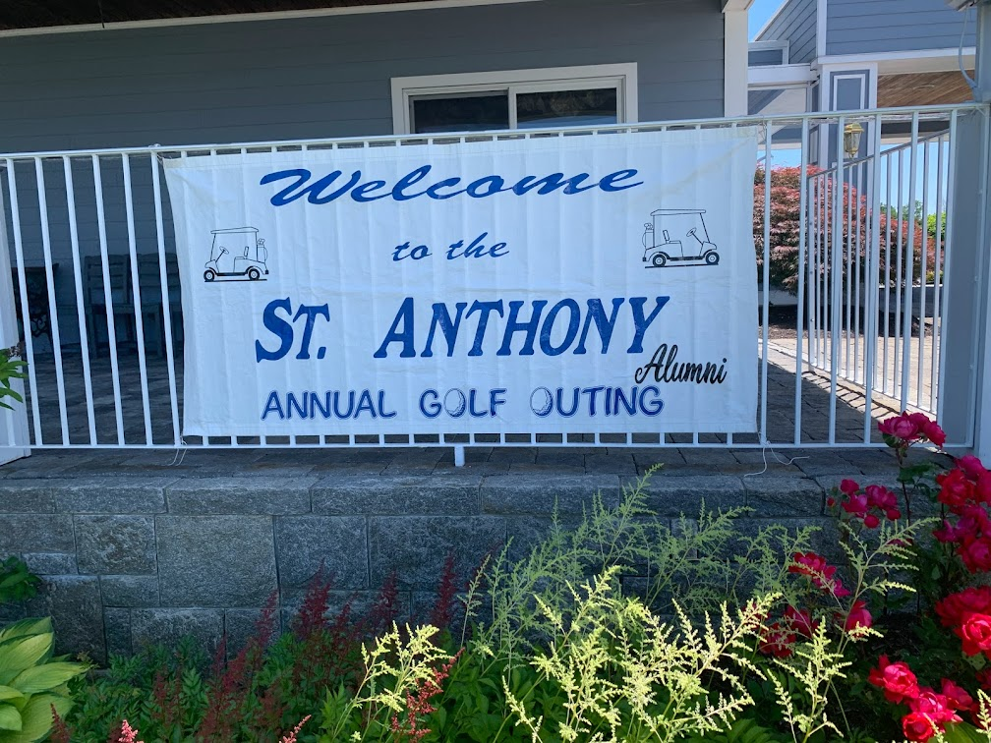


3rdAnnual St. Anthony Alumni Scholarship Golf Tournament
June 24, 2024 Fairview Country Club, Harwinton, CT

The St. Anthony School Alumni would like to invite you to support our 3rd Annual Golf Tournament Fundraiser. Proceeds will benefit families affiliated with St. Joseph Parish for scholarships for Catholic education from Pre-K to college. Your gift will ensure that excellence and opportunities in Catholic education will continue for families seeking to live a life of service to others grounded in faith.

Below you will find our different sponsorship levels. Please make your selection and return the form with payment payable to: St. Joseph Parish SAS Alumni Scholarship, 31 Oak St., Winsted, CT 06098.

Sponsorship levels:
___Gold Sponsor $1000 (Banner for sponsor in the dining room)

___Silver Sponsor $ $500 (Banner for sponsor in dining room)

___Tee Sponsor $ 150 (signs at tees)

___Contest Sponsor $ 250 (longest drive, closest to pin, etc.)

___Raffle Sponsor Item to be used as Raffle Prize, picked up by June 19th

Contact Name: ___________________________________ Phone #: __________________________

Business Name: _____________________________________________________________________

Address: ___________________________________________________________________________

Visa/MC/Disc/Amex # _______________________________________ Exp_______ CVC#_____

Name (on card) ______________________________Email address: _____________________________


