Why a Child's First Holy Communion is a Big Deal
Apr 21, 2017 By Whitney Hetzel |

Pope Francis has called it the "Sacrament of Love":
For children who are preparing to receive their First Holy Communion, this is a big deal. And for all of us, no matter how many times we have received Our Lord in the Holy Eucharist, it should always be a big deal.
What makes it so special the first time is the same thing that makes it special every time!
Jesus comes to us in a unique way in the Eucharist. When He comes, we receive Him into our body and our soul. This is very beautiful, personal, and intimate. We should not take it for granted!
This is why the first time a family member makes their Holy Communion, it is an exciting event for the whole family. The boy or girl preparing for this sacrament is going to be united with Jesus in a way that they never have before!
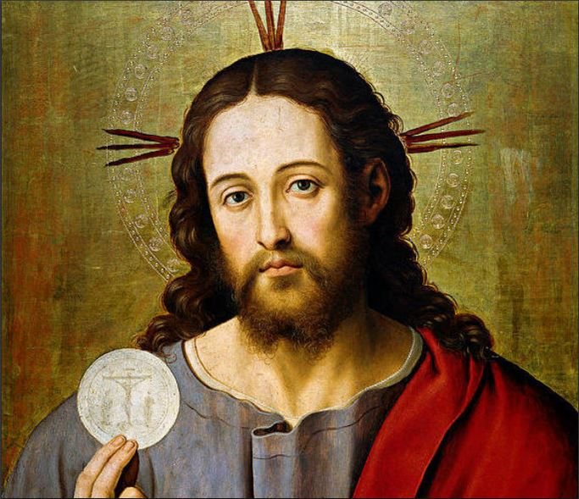
It is such a holy, joyful occasion. Our souls become the bride of Christ. That is why girls wear white dresses and boys wear suits. Relatives are invited. Parents take pictures. We celebrate. And the very act of celebrating reveals our belief in the True Presence of Jesus in the Eucharist.
First Holy Communion is, without question, a time of great joy. The saints in heaven, who are delighted to intercede for us, are celebrating along with your family.
St. Mother Teresa also has words for you and your family: "Jesus has made Himself the Bread of Life to give us life. Night and day, He is there. If you really want to grow in love, come back to the Eucharist..."
Yes, the celebration of a child's First Holy Communion IS a big deal. Don't let anyone tell you otherwise!

