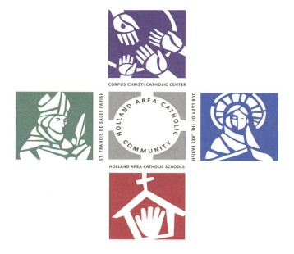
Corpus Christi Foundation
Guidelines – 2026 Grants

Thank you for your interest in applying for funding from the endowment earnings of the Corpus Christi Foundation. The mission of the Corpus Christi Foundation is to work toward providing a financial base that supports the religious, educational, ministerial, and charitable needs of Corpus Christi Catholic School and Center, Our Lady of the Lake and St. Francis de Sales Parishes. In keeping with the Gospel message, the foundation strives to build financial security for future generations by maintaining permanent endowment funds and encouraging stewardship of current and future planned gifts.
Listed are guidelines that must be followed when applying for funds:
- Projects that are innovative, collaborative, and/ or integrate our Catholic community are encouraged.
- Projects that relieve financial deficits, fund general administrative costs, or grants made to individuals will not be considered.
- Projects should have clear and measurable results or outcomes.
- There is no minimum amount for which you may apply.
- The Foundation’s goal is not to be the single source of funding for all projects. We endeavor to distribute funds to all entities. We suggest a funding cap of $1,500 per project, but would consider funding larger projects, especially those that integrate our Catholic community.
- If you submit multiple applications, please rank them in order of importance on each application by indicating if this is your first, second, or third choice.
- If the total cost of your project were to exceed the funded amount, please identify your other source of funds.
- Following are additional items considered when applications are reviewed:
  - The project has direct impact on evangelizing the Catholic faith or improving academic success
  - The project has lasting impact
  - The number of people the project impacts
Process:
Grant application forms are available at the parishes, school, and on the CCF website. If you have any questions, please contact Karen Brown (kgbrown22@yahoo.com) prior to the due date.
- To be considered, applications must be submitted by 5:00 PM on Friday, December 5, 2025.
- Each application requires two signatures, the applicant’s and the pastor’s or principal’s. However, if the application is a joint project (e.g., between two parishes, or parish(es) and school), the application must be signed by the applicant and by both pastors or by pastor(s)/principal, as applicable.
- All applicants will be notified by February 6, 2026 of the decision regarding their application.
- Checks for awarded grants will be mailed to your pastor or principal, earmarked for your grant.
Finally, we ask that you report the results of your project by completing a CCF Grant Evaluation Form when requested. As a part of the CCF Grant Evaluation Form, please note that receipts will need to be submitted for items purchased with grant funds.

The Distribution Committee of the Corpus Christi Foundation

