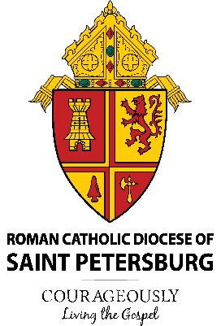

Diocese of Saint Petersburg – Office of Archives and Records
Hurricane Preparedness for Parishes and Schools
After the Flood: Advice for Salvaging
Did you know that www.fema.gov has excellent tools to recover family treasures from a disaster. The simple steps and instructions on their website could help our parishes and schools recover items. A few quick tips:
- Prioritize: Focus on what’s most important to save.
- Create Space: Spreading things out to dry takes up a lot of space.
- Handle with Care: Use great caution when handling items, which can be especially fragile when wet.
Quick Tips
Gentle air drying is best -indoors if possible. Increase indoor airflow with fans, open windows, air conditioners and dehumidifiers.
- Never pull apart wet photographs that are stuck together.
- Clean photographs by rinsing carefully in clean water.
- Air dry photos on a plastic screen or paper towel, or by hanging them by the corner with plastic clothespins.
- Don’t let the image come into contact with other surfaces as it dries.
If you have any questions or concerns, please contact the Office of Archives & Records at (727) 344-1611, Ext. 5383.
Be well. Be prepared. Be safe!

