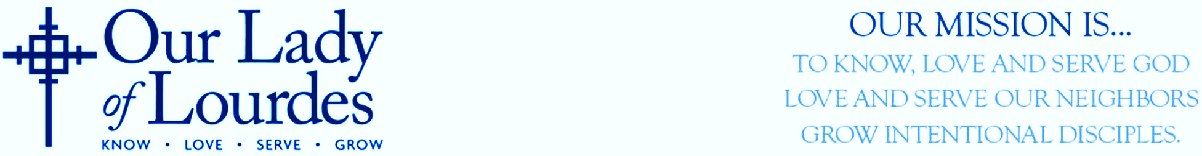

BAPTISM INFORMATION & SCHEDULE FOR 2026 and 2027

Important

If you wish to enroll your infant in our faith community for Baptism, kindly reach out to Fr. David, our pastor, at dsanchez@ourlourdes.org or via phone at (502) 896-0241. If child is attending our school Family Catechesis is not required. For children above the age of 5, enrollment in the Family Catechesis is a prerequisite for Baptisms during the Easter Vigil. Please remember, your family should be registered for at least 6 months before you request the Sacrament.

What is the Sacrament of Baptism?
The sacrament of Baptism ushers us into the divine life, cleanses us from sin, and initiates us as members of the Christian community. It is the foundation for sacramental life. At Baptism, the presider prays over the water:

Father, look now with love upon your Church, and unseal for her the fountain of Baptism. By the power of the Holy Spirit give to this water the grace of your Son, so that in the sacrament of Baptism all those whom you have created in your likeness may be cleansed from sin and rise to a new birth of innocence by water and the Holy Spirit. (Christian Initiation of Adults, #222A)

Classes
Class will be on Wednesday at 6:30 pm on the week of the scheduled Baptism (unless otherwise noted). Both Parents and Sponsors must be present at class, even if you have previously attended the class. The child does not need to be present. Baptism will take place as scheduled. Baptisms will take place during the Weekend Liturgy at Parent’s Mass Preference (Saturday at 4:30 pm/Sunday 7:30 am, 9:30 am, and 11:30 am). Please be advised that these dates and times might change due to unforeseen circumstances. For the latest updates, kindly refer to our bulletin, website, newsletter, Parish App or contact the Parish Office. Children will be baptized at the font. Male Sponsors are expected to bring a Baptismal candle. Female Sponsors or witnesses are to bring a towel to dry the infant’s head.

Schedule

2026
Baptism Date | Class Date
August 29 and 30 | August 26
October 24 and 25 | October 21
December 26 and 27 | December 16

2027
Baptism Date | Class Date
January 30-31 | January 20
March 27 | March 17
April 24-25 | April 4
June 26-27 | June 16
August 28-29 | August 18
October 30-31 | October 20
December 26 | December 15

Additional Information

Parents and Sponsors should arrive at church 30 minutes prior to the Mass.

Infants should be dressed in non-white clothing and will be changed into a Baptismal gown or white garment after infant’s Baptism.

Order of Service

- Parents and Sponsors or witnesses will be received at the vestibule of the Church. Families will be seated at the nave of the sanctuary.

- Parents and Sponsors are invited to the front of the altar for anointing with the Oil of the Catechumens.

- Each family (Parents, infant, Sponsors, witnesses, siblings, and guest members of the family) will be invited to the Baptismal Font for the Baptism.

- Baptism.

- Child will be vested with white garment at the rear of the church (please do not cover the child’s head). After each Baptism Parents and Sponsors will return to the front of the altar with the infant. Other members of the family and guests can return to their seats.

- Anointing with The Chrism and presentation of the Light of Christ (Baptismal Candle).

- Effetha.

- Final Blessing.

The church will be open for a short time after the service for photos if desired.

