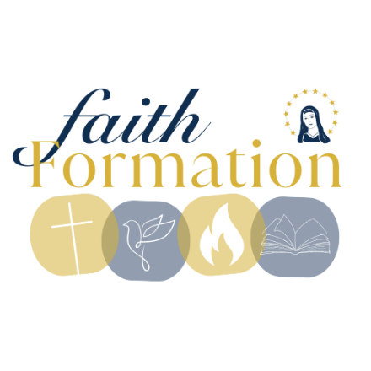
QUEEN OF THE MIRACULOUS MEDAL FAITH FORMATION
2026-2027 CALENDAR
All sessions run from 10:30-11:45 in Queens’ school classrooms
Sessions in blue begin with a group gathering in either the cafeteria or gym (parents welcome and encouraged to attend with your children!)



SESSION DATES LOCATION___________
Sunday, August 30, 2026 Parent Meeting/First Day of Class Cafeteria/Classrooms

Sunday, September 6, 2026 Labor Day, no Faith Formation

Sunday, September 13, 2026 Classrooms

Sunday, September 20, 2026 Classrooms

Sunday, September 27, 2026 Classrooms

Sunday, October 4, 2026 Classrooms

Sunday, October 11, 2026 Classrooms
8th Grade Confirmation Candidates, Rite of Enrollment, 9:00am Mass

Sunday, October 18, 2026 Fall Break, no Faith Formation
Sunday, October 25, 2026 Classrooms

Sunday, November 1, 2026 All Saints Day Party Cafeteria/Gym
Sunday, November 8, 2026 Classrooms

Sunday, November 15, 2026 Classrooms
2nd Grade First Reconciliation Retreat 2:00-4:15 School/Church (No class 2nd grade only)

Sunday, November 22, 2026 Classrooms
First Confirmation Mini-Retreat 12:00-2:00 (Location: Queens. No class 8th grade only)

Sunday, November 29, 2026 Thanksgiving Break, no Faith Formation

Thursday, December 3, 2026 First Reconciliation Dinner/Service 5:30 Vincentian Hall/Church

Sunday, December 6, 2026 Classrooms

Sunday, December 13, 2026 Classrooms

Sunday, December 20, 2026 Classrooms

Sunday, December 27, 2026 Christmas Break, no Faith Formation
Sunday, January 3, 2027 New Year’s Break, no Faith Formation

Sunday, January 10, 2027 Classrooms

Sunday, January 17, 2027 Classrooms
Second Confirmation Mini-Retreat 12:00-2:00 (Location: St. John’s. No class 8th grade only)

Sunday, January 24, 2027 Classrooms

Sunday, January 31, 2027 Candlemas Procession/Presentation Gym/Church/Classrooms of the Lord

Sunday, February 7, 2027 Classrooms

Sunday, February 14, 2027 President’s Weekend, no Faith Formation

Sunday, February 21, 2027 Circle of Grace Day Classrooms

Sunday, February 28, 2027 Classrooms

Sunday, March 7, 2027 Group Stations of the Cross Gym/Classrooms

Sunday, March 14, 2027 Classrooms
Third Confirmation Mini-Retreat 12:00-2:00 (Location: St. Mary’s. No class 8th grade only)

Sunday, March 21, 2027 Palm Sunday Gym/Classrooms
Sunday, March 29, 2027 Easter Sunday, no Faith Formation
Sunday, April 4, 2027 Spring Break, no Faith Formation

Sunday, April 11, 2027 Classrooms
2nd grade First Communion Retreat 2:00-4:15 School/Church (No class 2nd grade only)

Sunday, April 18, 2027 Classrooms

Sunday, April 25, 2027 Classrooms

Sunday, May 2, 2027 Classrooms
2nd grade First Holy Communion Mass 1:30pm Church (No class 2nd grade only)

Sunday, May 9, 2027 Mother’s Day/May Procession Gym/Memorial Garden/Classrooms

Sunday, May 16, 2027 Classrooms
Family Fun Fest following last day of Faith Formation! 11:45-2:30

