St. Thomas’ 2022-2023 Faith Formation Calendar
Wednesdays
6:00-7:15



Sept. 11 CATECHETICAL SUNDAY Jan. 11 CLASS
Sept. 14 CLASS Jan. 18 CLASS
Sept. 21 CLASS Jan. 25 CLASS
Sept. 28 CLASS


Oct. 5 CLASS Feb. 1 CLASS
Oct. 12 CLASS-LIVING ROSARY Feb. 8 CLASS
Oct. 19 CLASS Feb. 15 CLASS Oct. 26 CLASS Feb. 22 ASH WEDNESDAY

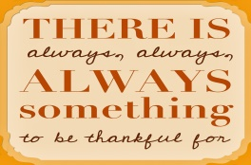  Nov.2 CLASS March 1 CLASS
Nov, 9 CLASS March 8 CLASS
Nov. 16 CLASS March 15 CLASS
Nov 23 THANKSGIVING MASS March 22 CLASS
Nov. 30 CLASS March 29 CLASS


Dec, 7 CLASS/Reconciliation April 5 SPRING BBREAK
Dec, 14 CLASS April 12 CLASS
Dec, 21 CLASS April 19 CLASS
Dec, 28 CHRISTMAS BREAK April 26 CLASS

